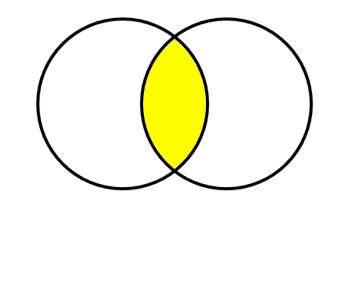
Combining keywords- Boolean Logic
Weight Loss Surgery
Cost Effectiveness

AND
Articles will contain information on weight loss surgery and cost effectiveness

Weight Loss Surgery
Cost Effectiveness


OR
Articles will contain information on either weight loss surgery or bariatric surgery
Weight Loss Surgery
Bariatric Surgery


NOT
Articles will contain information on weight loss surgery but not diabetes
Diabetes
Weight Loss Surgery

